VISIT WWW.OKETHICS.ORG FOR MORE INFORMATION ON UPCOMING EVENTS
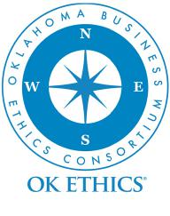 | OKLAHOMA BUSINESS ETHICS CONSORTIUM  TULSA CHAPTER EVENT, June 27, 2013  DOUBLETREE HOTEL DOWNTOWN | 11:30 AM TO 1:00 PM 616 WEST SEVENTH STREET | TULSA, OKLAHOMA
 | Recommended for 1 CPE in Ethics*
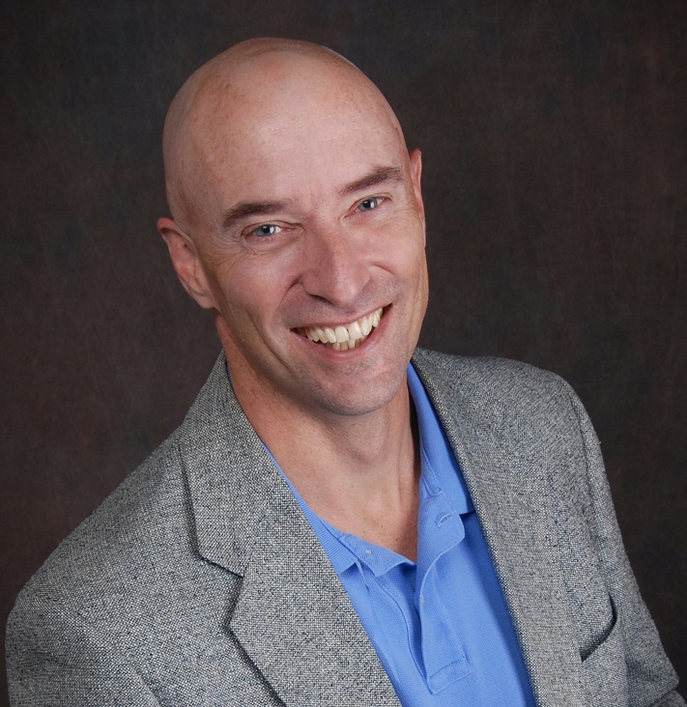  Unless otherwise noted, Tulsa events listed below will be held at the Doubletree Hotel | Downtown Tulsa  Unless otherwise noted, OKC events listed below will be held at: The Petroleum Club | 100 North Broadway Avenue | Oklahoma City |  | “Building Trustworthy Organizations…One Leader,  One Team at a Time”  Rob Benson, Learning Unlimited  The late Stephen Covey noted that trust “is the most essential ingredient in effective communication. It’s the foundational principle that holds all relationships.” Rob Benson, Lead Consultant at Learning Unlimited Corporation, will discuss the business value of trust and the impact of low trust on employee’s ability to ethically fulfill their responsibilities. Attendees will experience a trust building sequence and then discuss practical steps that leaders can take to develop more trusting – and trustworthy – organizations.

FOR UPCOMING EVENTS VISIT www.okethics.org

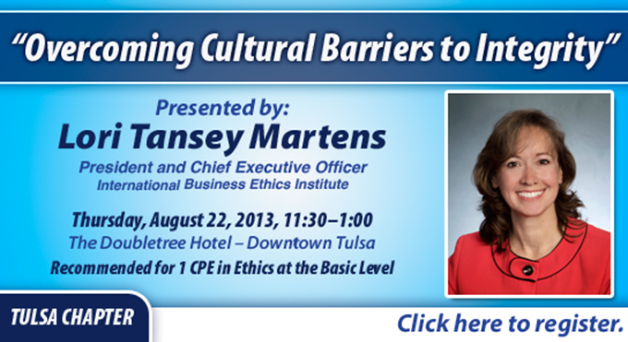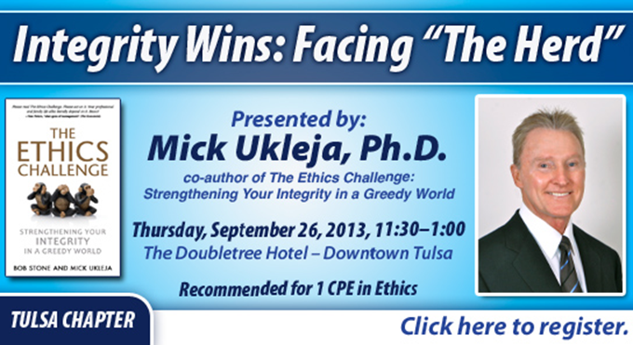

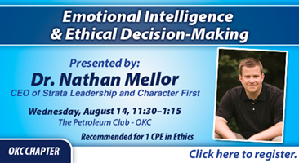
* CPE STATEMENT: It is the responsibility of participants to demonstrate applicability of each program as it relates to his/her area of practice. OK Ethics makes no guarantees. Also,
attendees must be present to accept CPE certificates and these will be issued at the back of the room upon the conclusion of the program. Please note that we do not have the manpower
capabilities to email these later. CPE certificate recipients must be registered on our attendance list to receive a certificate, so please be sure to check in with the registration team.

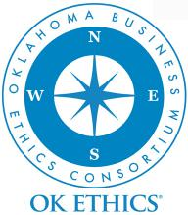
VISIT WWW.OKETHICS.ORG FOR MORE INFORMATION ON UPCOMING EVENTS

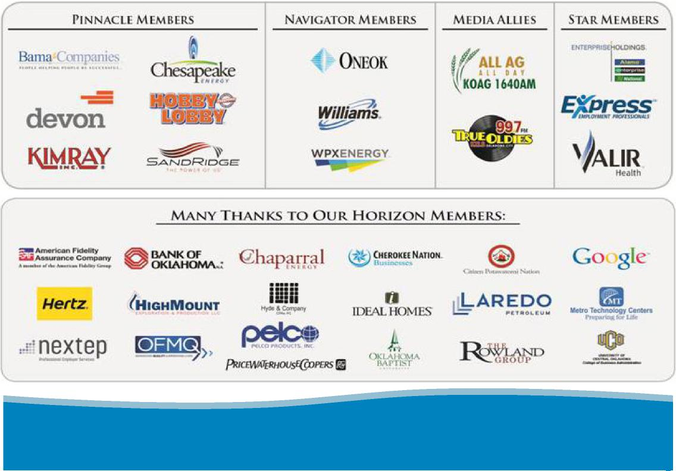
TULSA MEETINGS
Cost: Members—$25.00 and Non-Members—$35.00 | Reservations Required at okethics.org
For more details contact: Lynn Flinn | The Rowland Group | lynn@rowland-group.com | 918.836.1900 Kevin Kennemer | The People Group | kevin@thepeoplegroup.com | 888.797.9992
AGENDA
June 27, 2013
TULSA CHAPTER MEETING

- Welcome and Announcements  Lynn Flinn, The Rowland Group,  OK Ethics Chapter Founder  - Guiding Principle  Todd Lisle, BKD, LLP,  OK Ethics State Council President-Elect | - Speaker Introduction  Bart Brabham, Learning Unlimited  - Presentation  Rob Benson, “Building Trustworthy Organizations…One Leader, One Team at a  Time”
THANK YOU!
Many thanks to our volunteers and Legacy team members for making this and every other meeting possible: Tommy Campbell, David Christie,
Tom Clatfelter, Lynn Flinn, Alicia Goodloe, James Kelley, Kevin Kennemer, Jan Laub, Neal Lehman, Nick Minden, Michael Oonk, Doyle Paden,
Shere Rockwell, Steve Rockwell, John Stancavage, and Susie Wellendorf.
General Disclaimer: Members of the Oklahoma Business Ethics Consortium frequently share information concerning various issues and developments that may have legal implications. The discussions, commentary, and handouts at Consortium meetings or presentations to other organizations are for general informational purposes only. They cover only some aspects of the subject topic, and do not constitute a complete legal analysis of the topic or how it might apply to any particular set of facts. Before taking any action based on information presented during a Consortium event, participants are encouraged to consult a qualified attorney. The observations and comments of presenters at Consortium meetings and networking are the views and opinions of the presenter and do not constitute the opinion or policies of the Consortium or any of its members. Presenters are respectfully requested to avoid profanity, preaching, politics and self-promotion during their lectures.

